AI Skill Assessment Platform – Workflow
Abstract
The AI-Powered Technical Skill Assessment and Mock Interview Platform is a web-based application designed to help students assess and improve their technical skills for academic and career development. The system allows users to register and securely log in, take skill-based assessments, solve coding problems, participate in AI-powered mock interviews, and receive detailed performance feedback. It analyzes test and interview results to identify strengths and weaknesses and provides personalized learning recommendations and preparation plans. The platform also includes an AI study assistant using LLM and RAG technologies to answer questions from learning materials, along with features such as skill analytics, resume analysis, leaderboards, and progress tracking. The application uses React.js for the frontend, Spring Boot for the backend, MySQL for database management, JWT and Spring Security for authentication, and AI technologies for intelligent assessment and feedback, providing an integrated environment for continuous technical skill development.
Workflow
The following workflow shows the major user modules, Java full-stack architecture, database flow, AI/RAG integration, and deployment components of the proposed system.
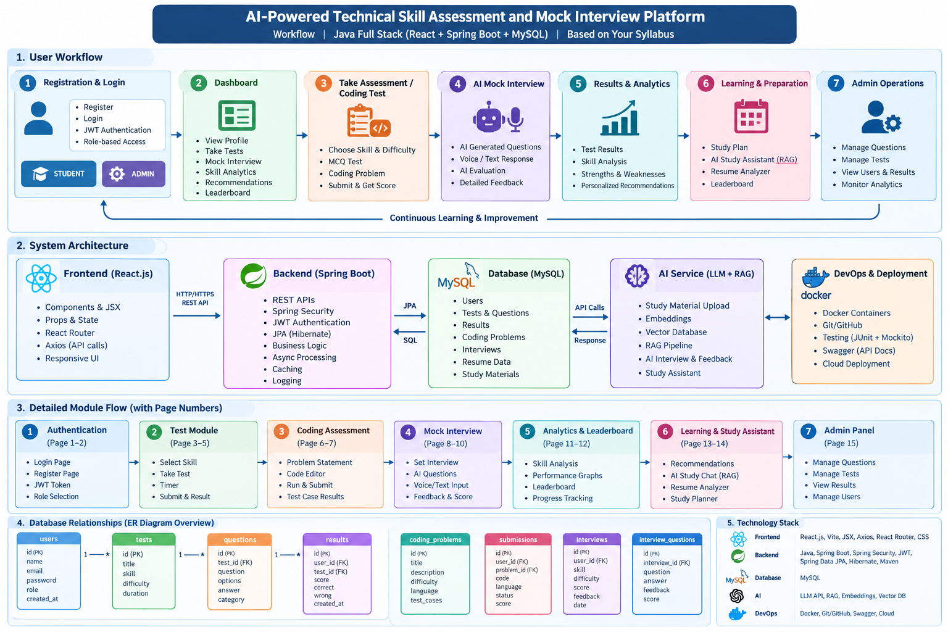
Figure 1: AI Skill Assessment and Mock Interview Platform – System Workflow

